**May 10, 2019**

**Model: GOA 18.1.0.**

CEATTLE TMB

Single Species Mode

Years: 1977 to 2018

Species: Pollock, Cod, ATF

|  |  |  |  |  |
| --- | --- | --- | --- | --- |
| **Survey** | **Selectivity** | **Catchability** |  |  |
| Pollock_summer_acoustic | Logistic | Analytical |  |  |
| Pollock_shelikof_acoustic | Logistic | Analytical |  |  |
| Pollock_bottom_trawl | Logistic | Analytical |  |  |
| Pollock_adfg | Logistic | Analytical |  |  |
| Pcod_bt_survey | Non-parametric | Analytical |  |  |
| Pcod_ll_survey | Non-parametric | Analytical |  |  |
| ATF_bottom_trawl | Logistic | Analytical |  |  |
|  |  |  |  |  |
| **Fishery** |  |  |  |  |
| GOA_pollock | Logistic |  |  |  |
| Pcod_trawl | Logistic |  |  |  |
| Pcod_longline | Logistic |  |  |  |
| Pcod_pot | Logistic |  |  |  |
| GOA_atf | Non-parametric |  |  |  |

Figure 1. Fits to survey indices of abundance

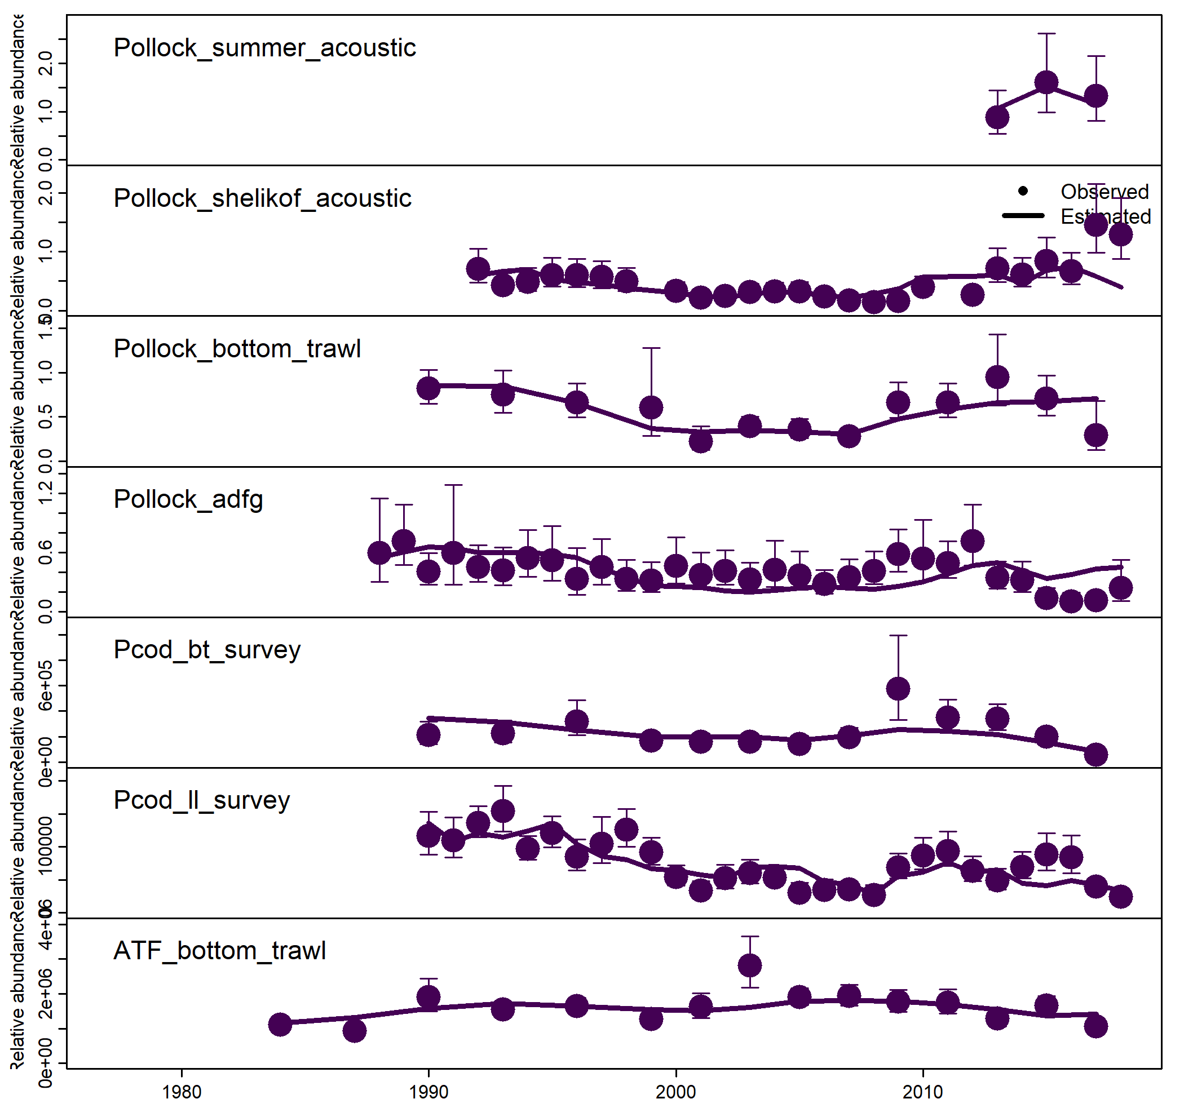

Figure 2. Fits to catch.

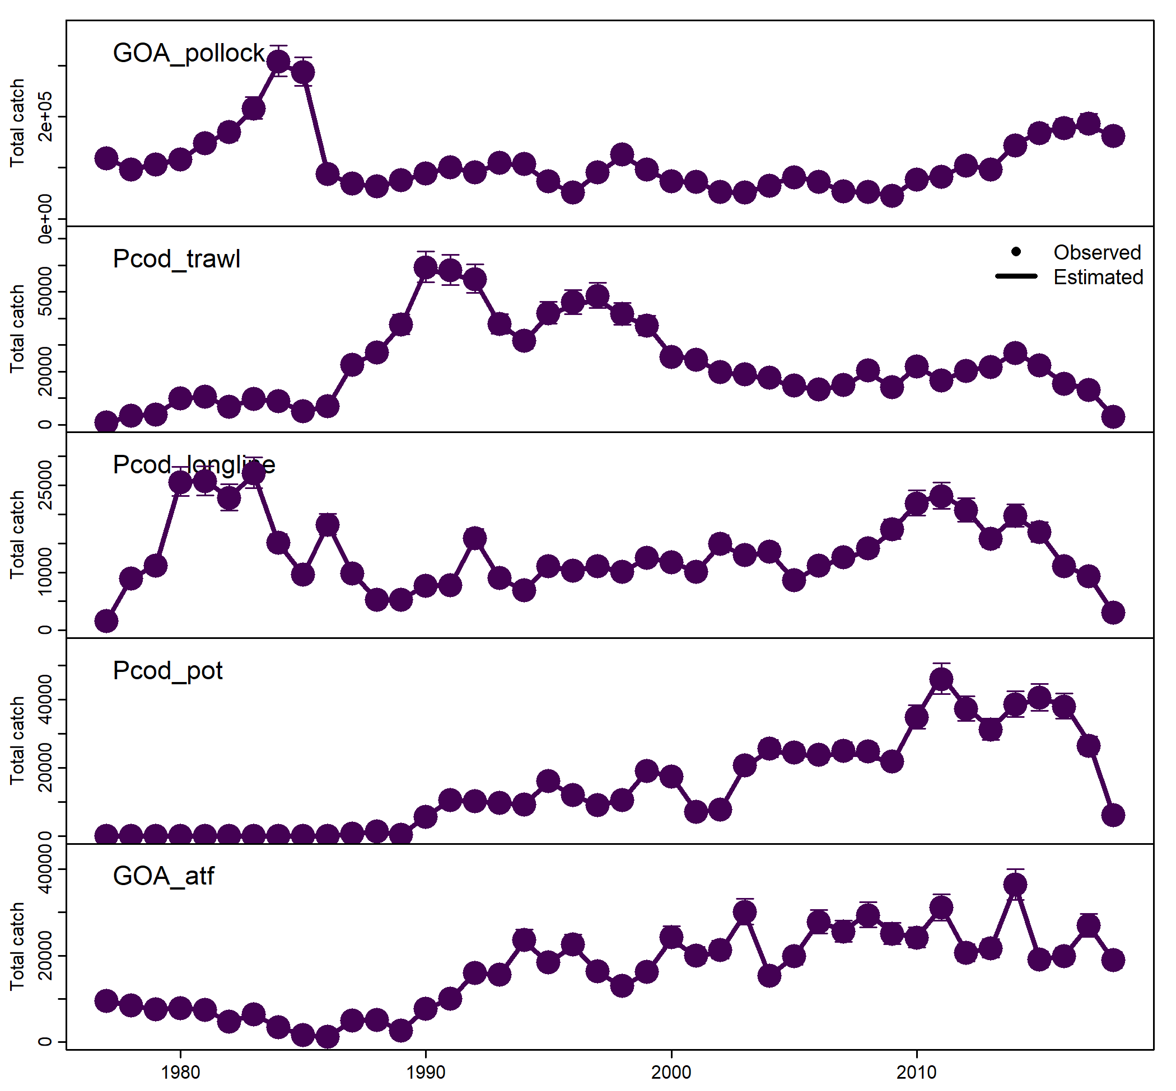

Figure 3. Selectivity

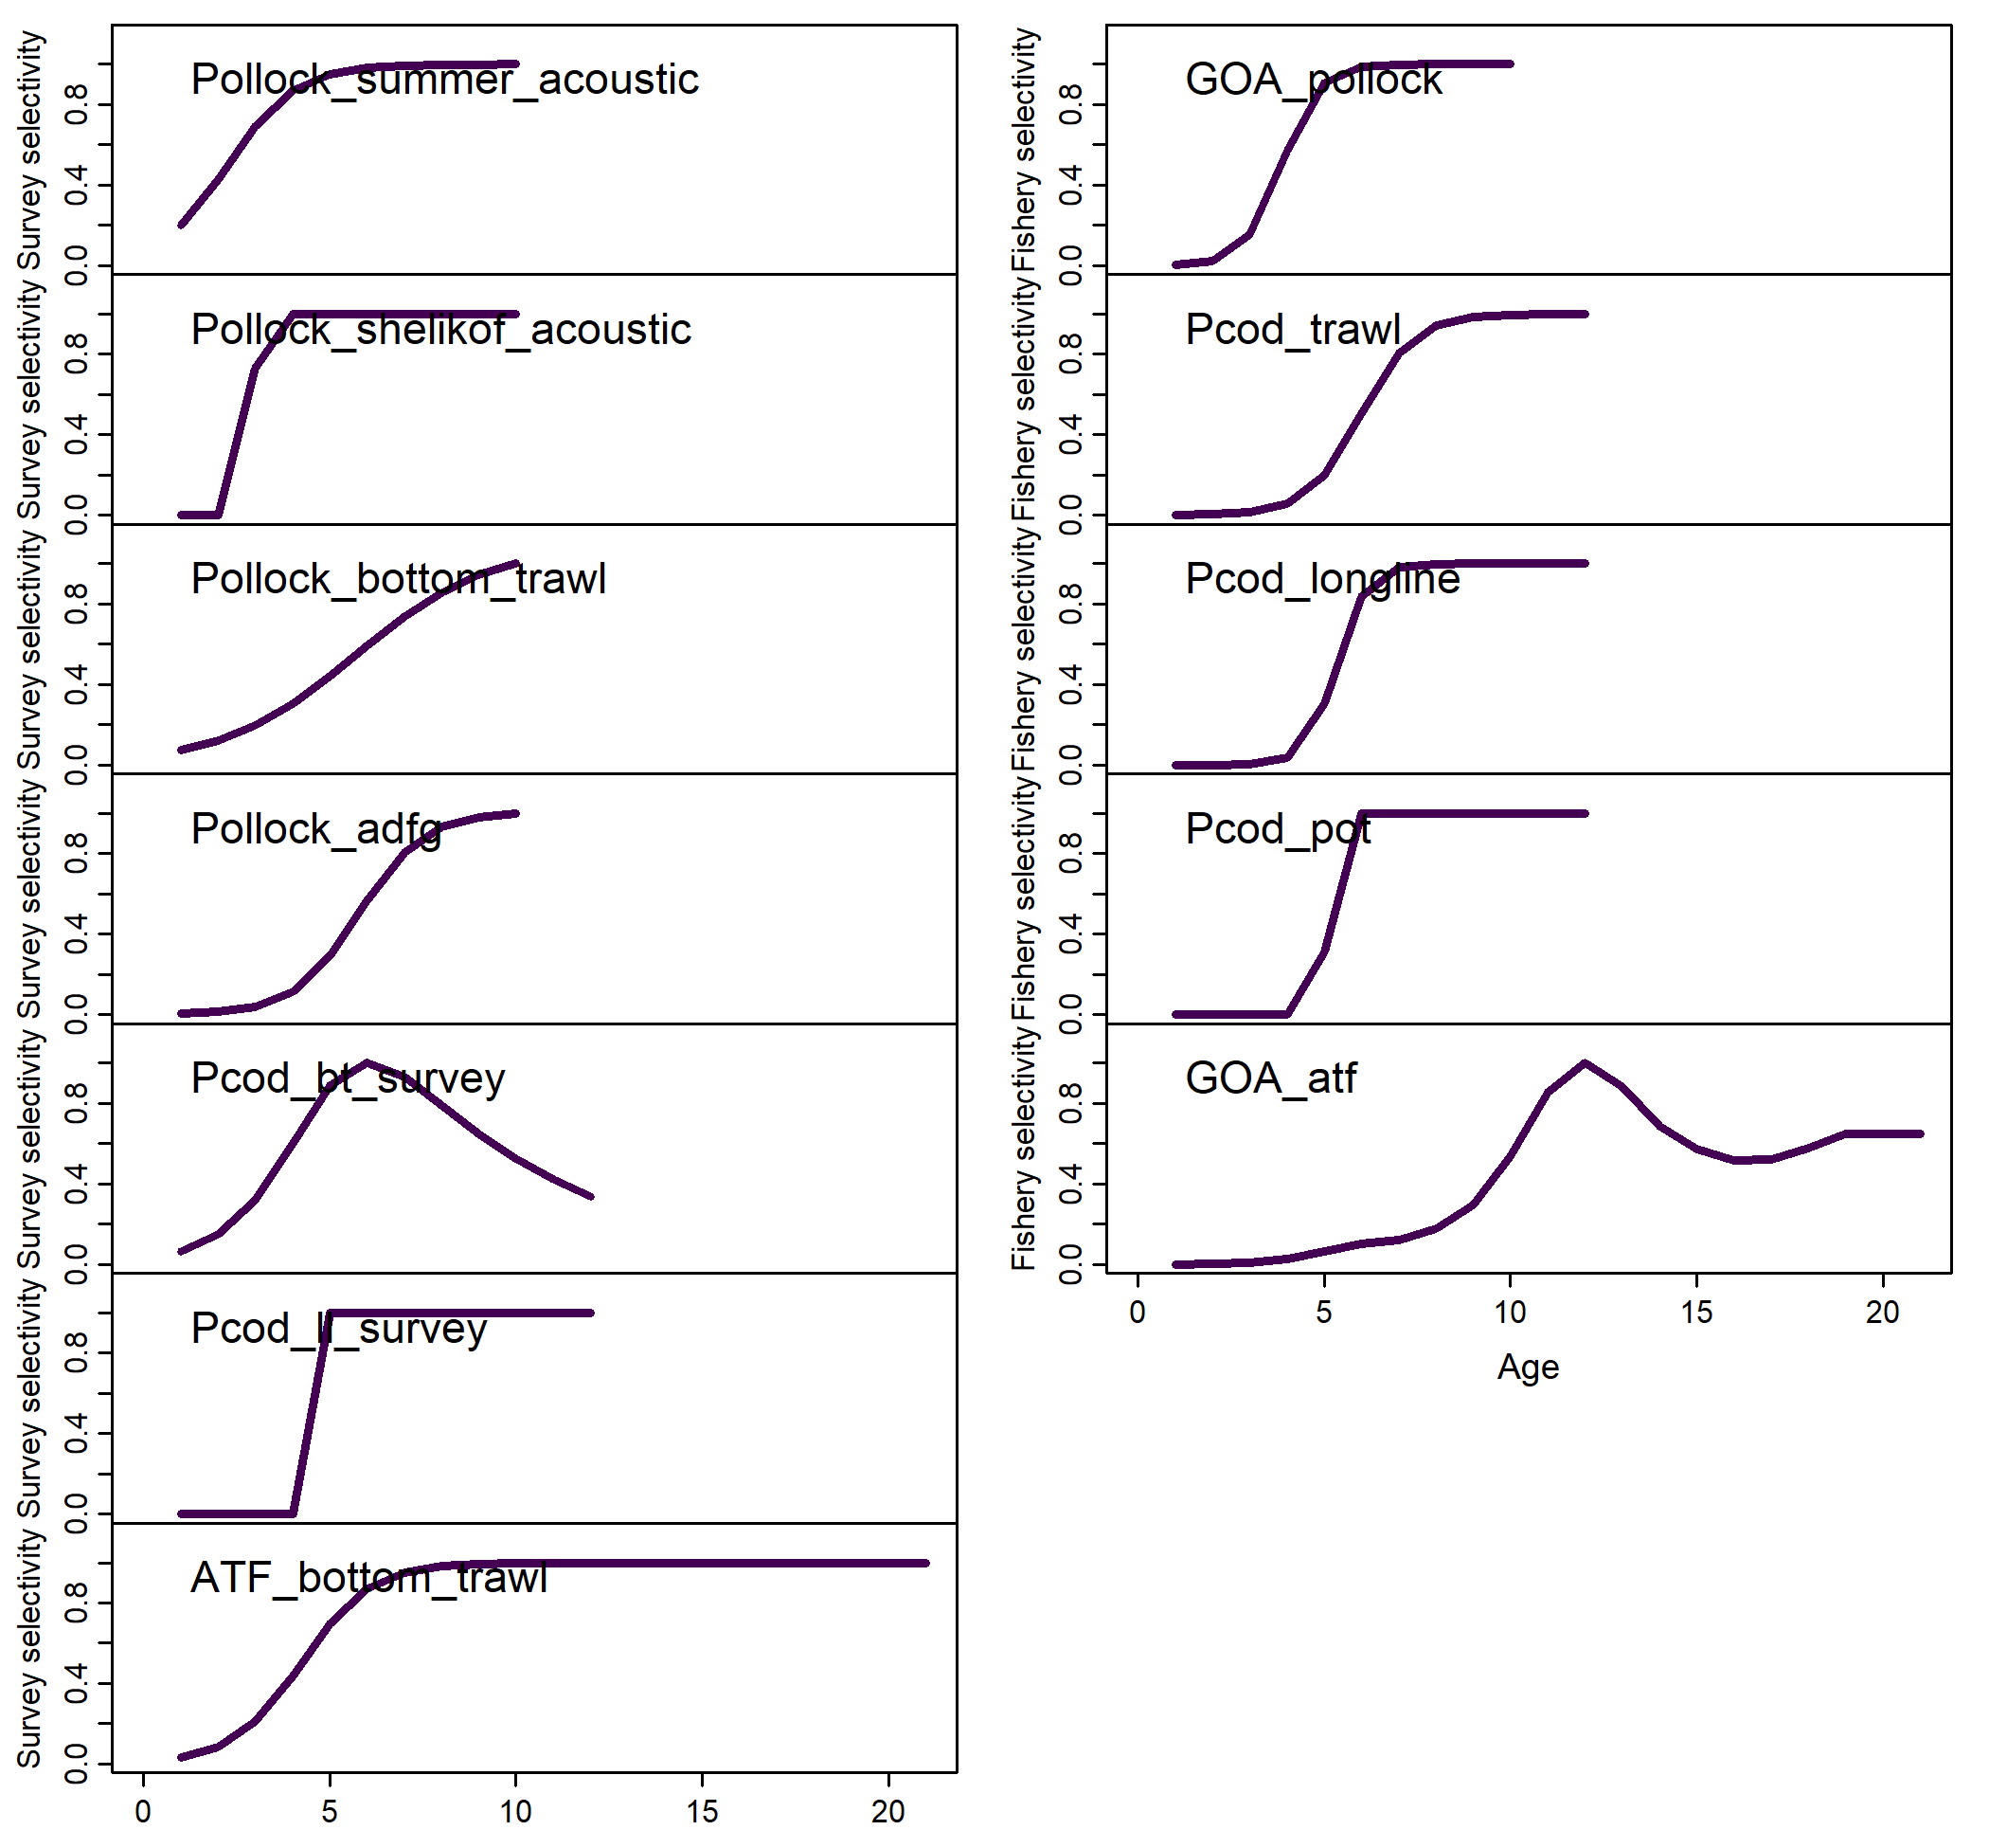

Figure 4. Pearson residuals of survey age comp.

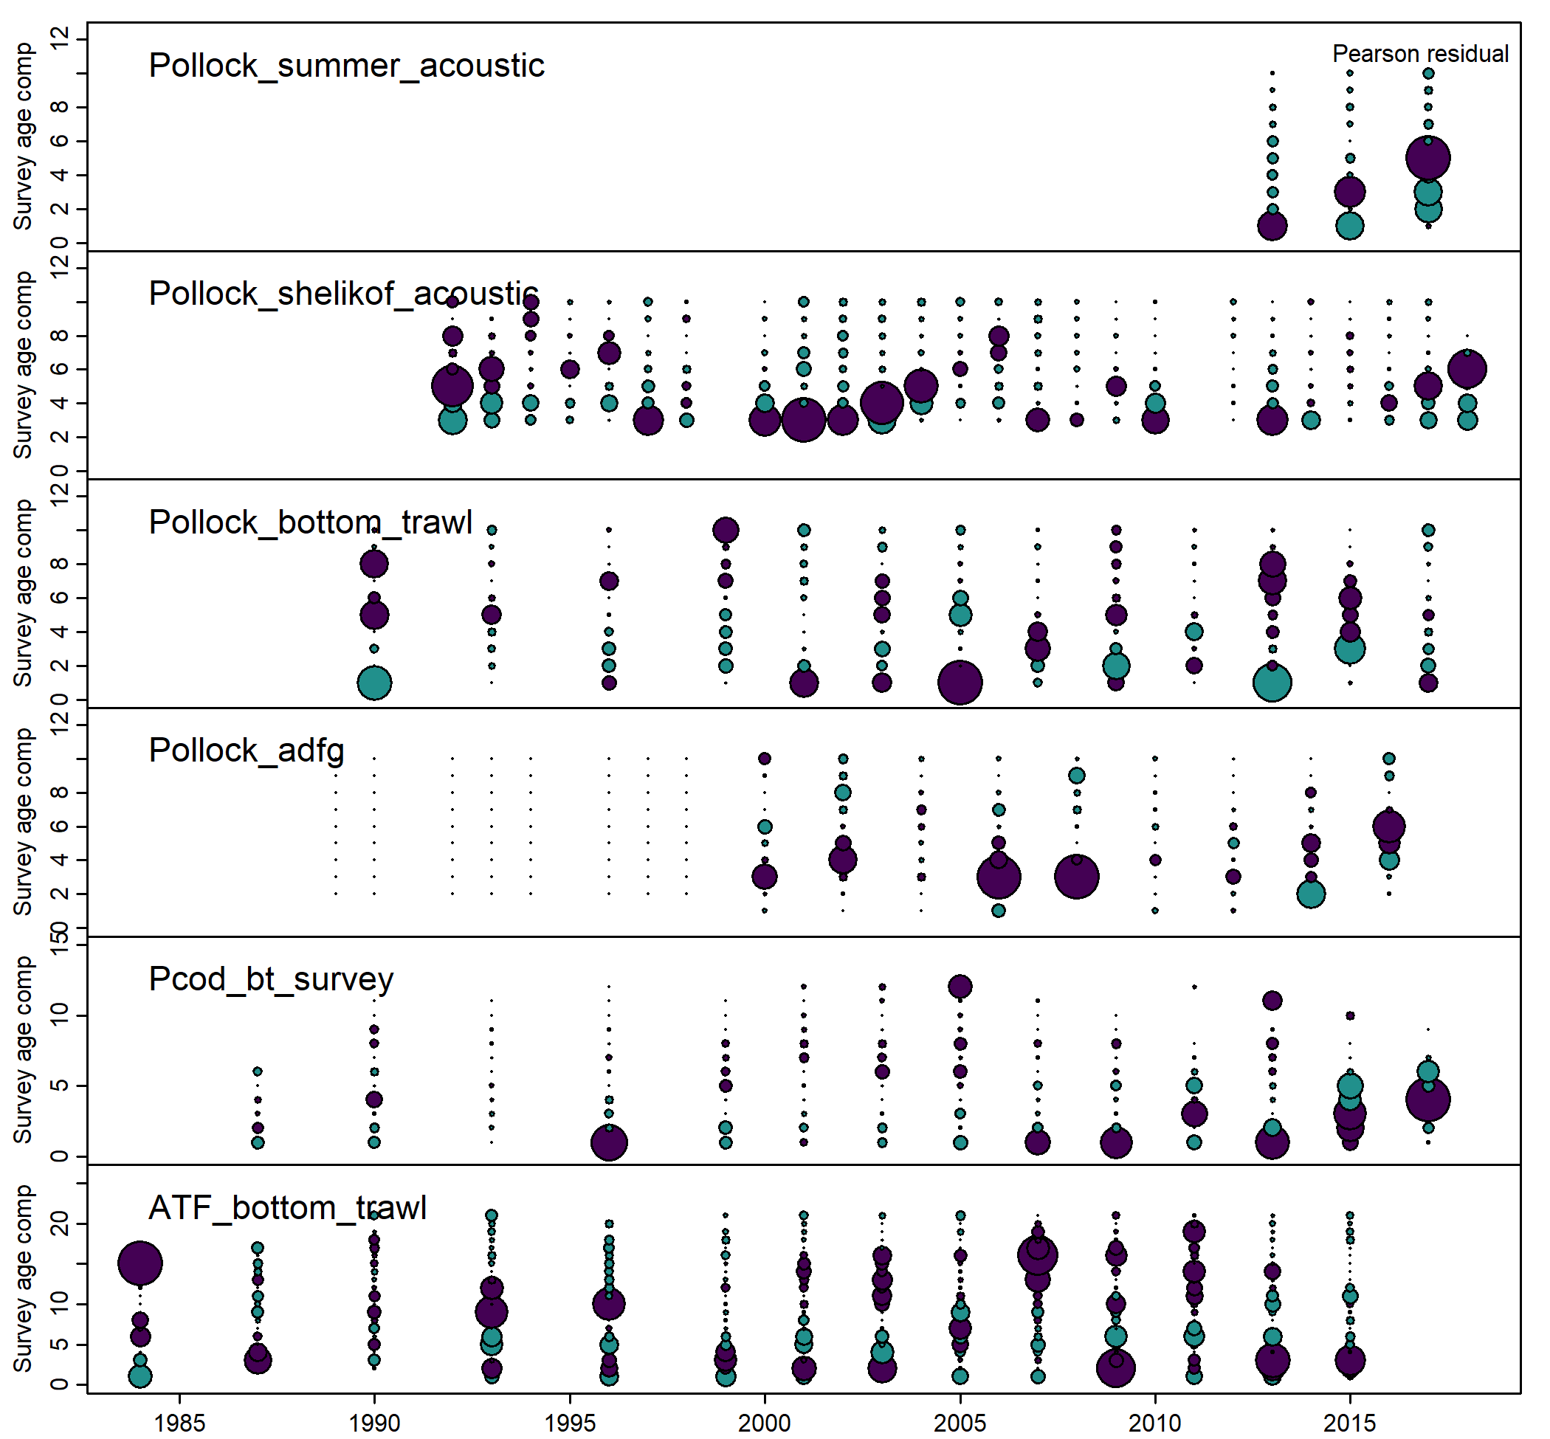

Figure 5. Pearson residuals of survey length comp.

Figure 6. Pearson residual of fishery age comp.

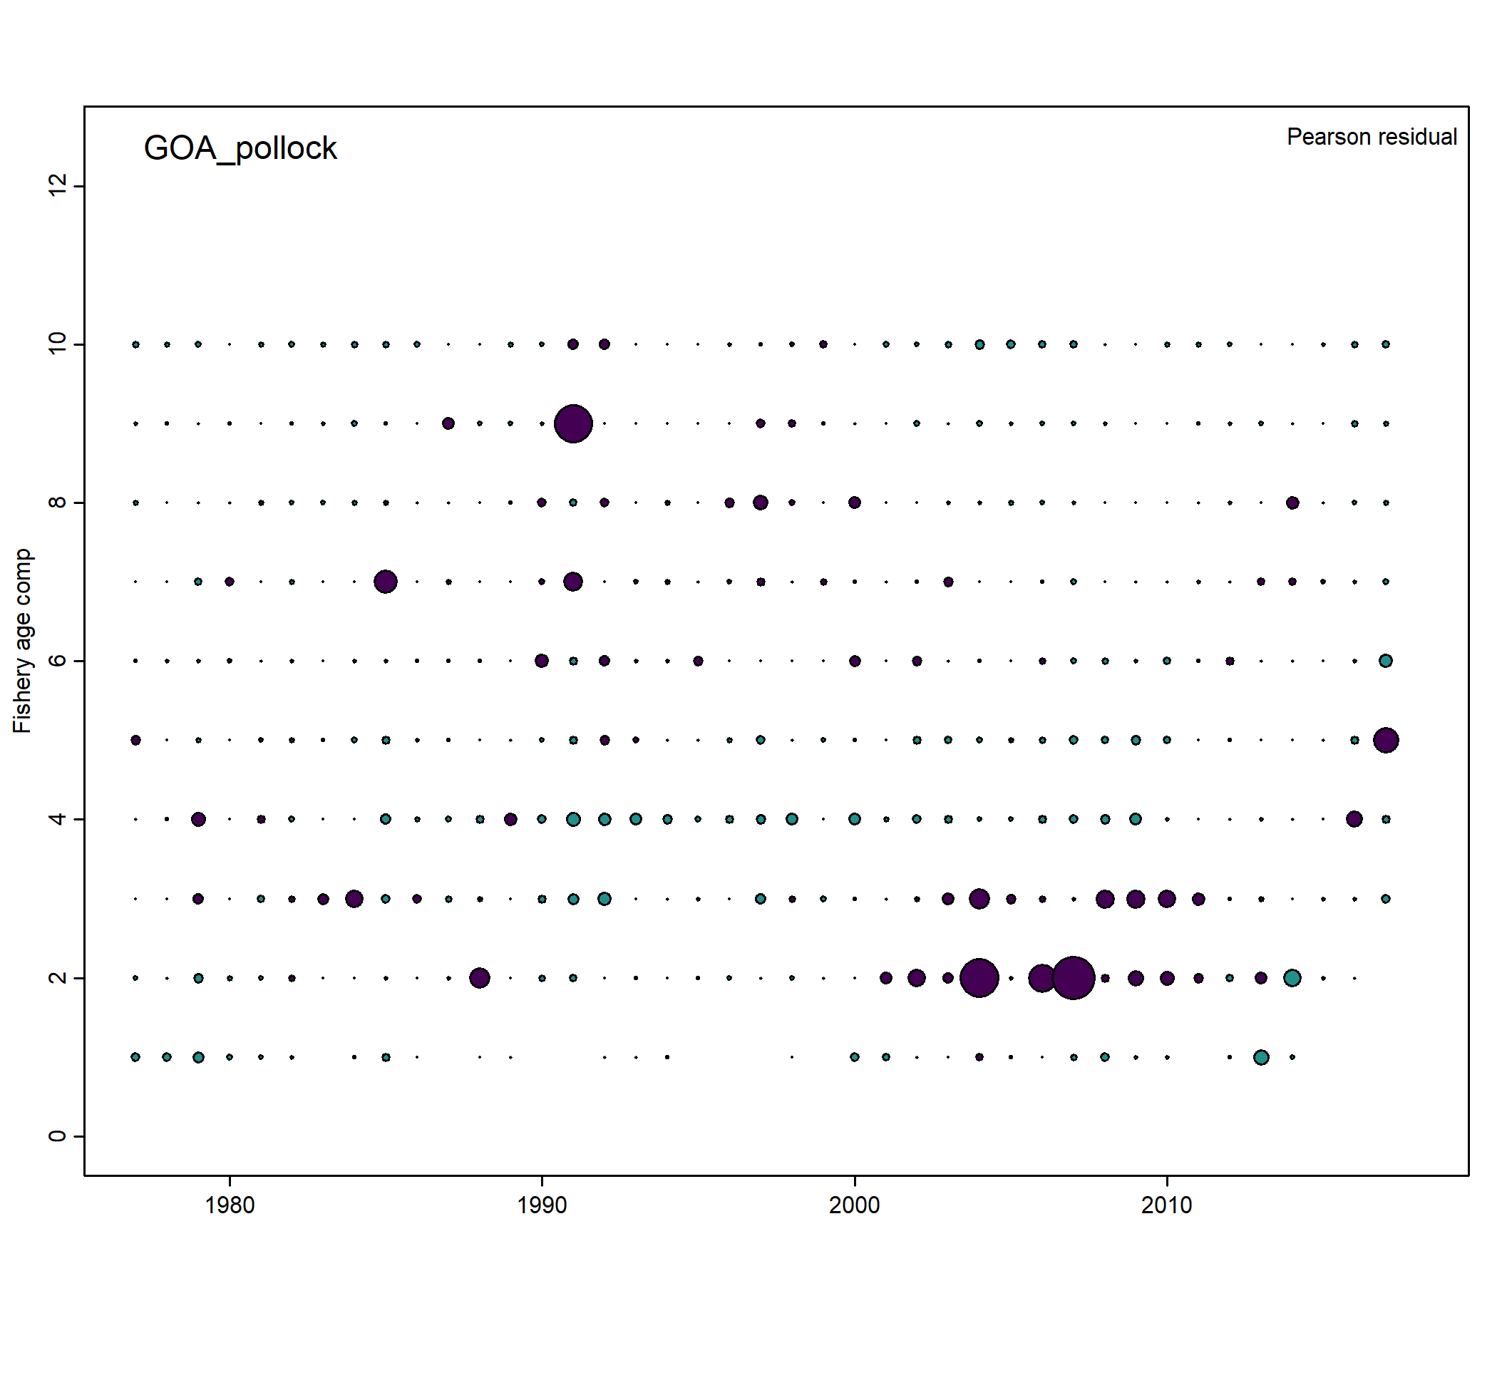

Figure 7. Pearson residual of fishery length comp.

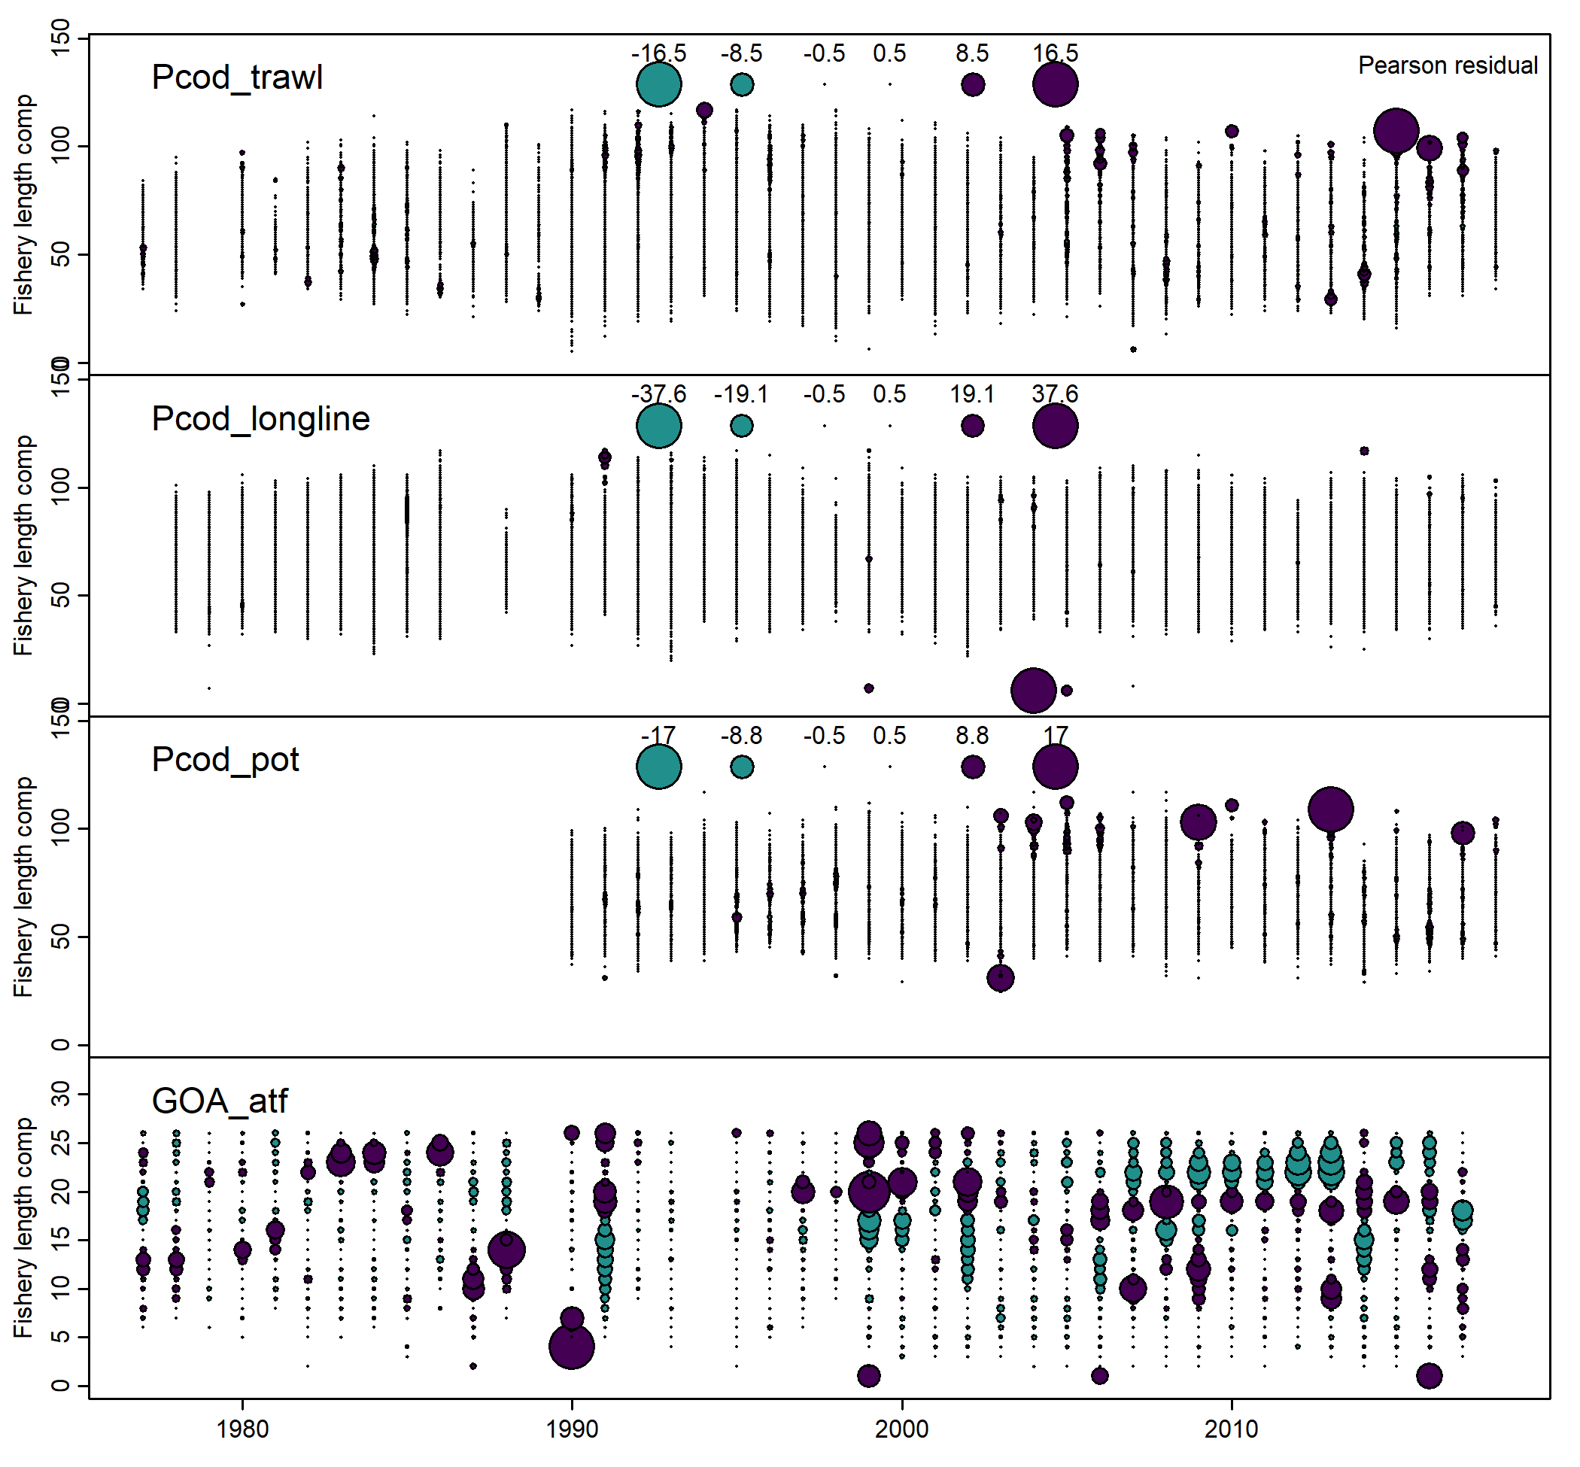

Figure 8. Aggregated fit to survey age comp.

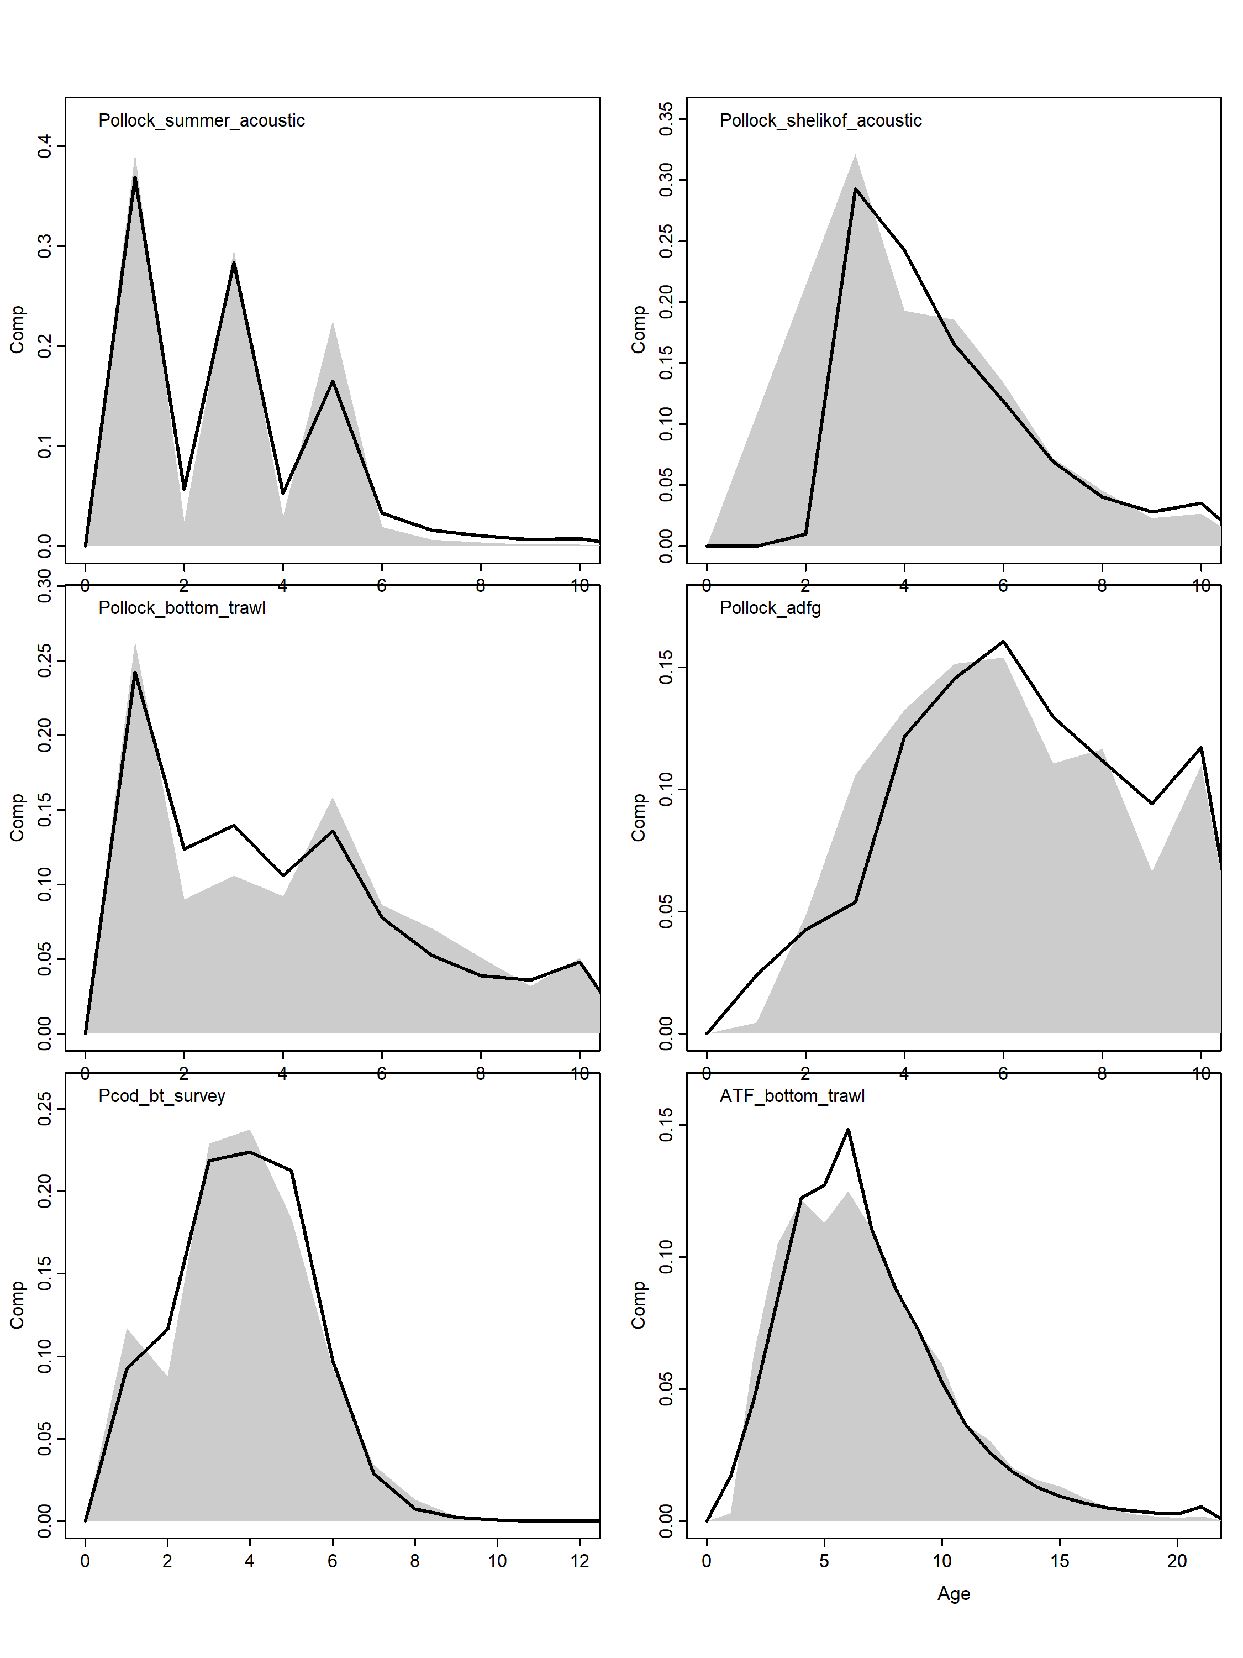

Figure 8. Aggregated fit to survey length comp.

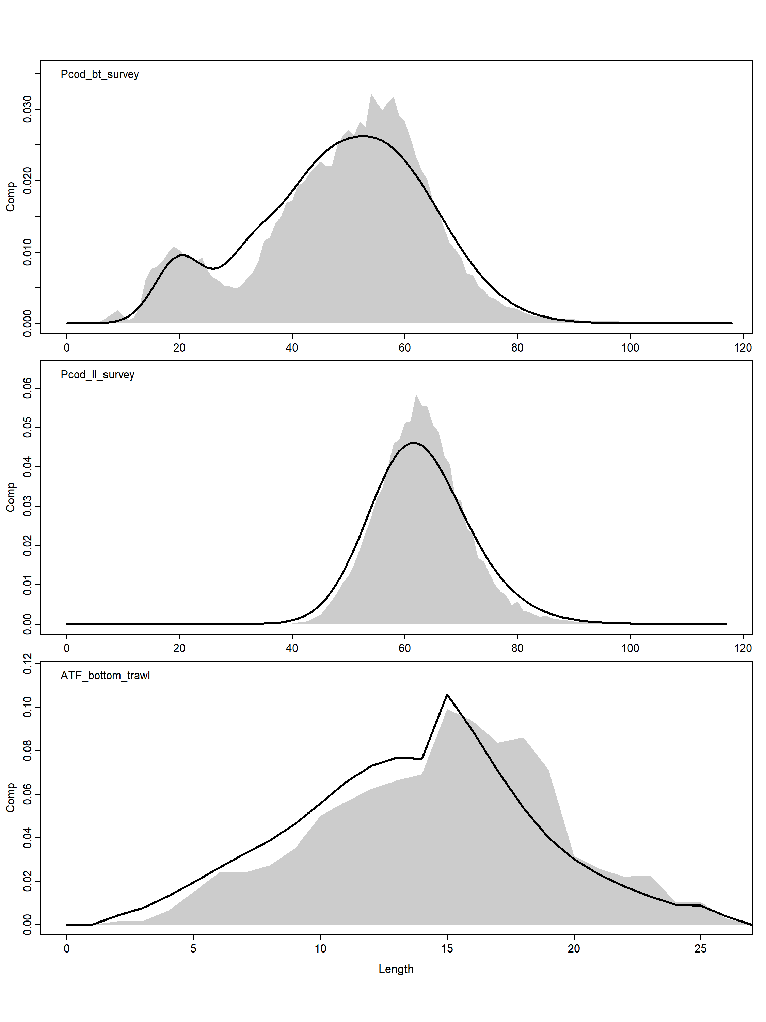

Aggregated fit to fishery age comps

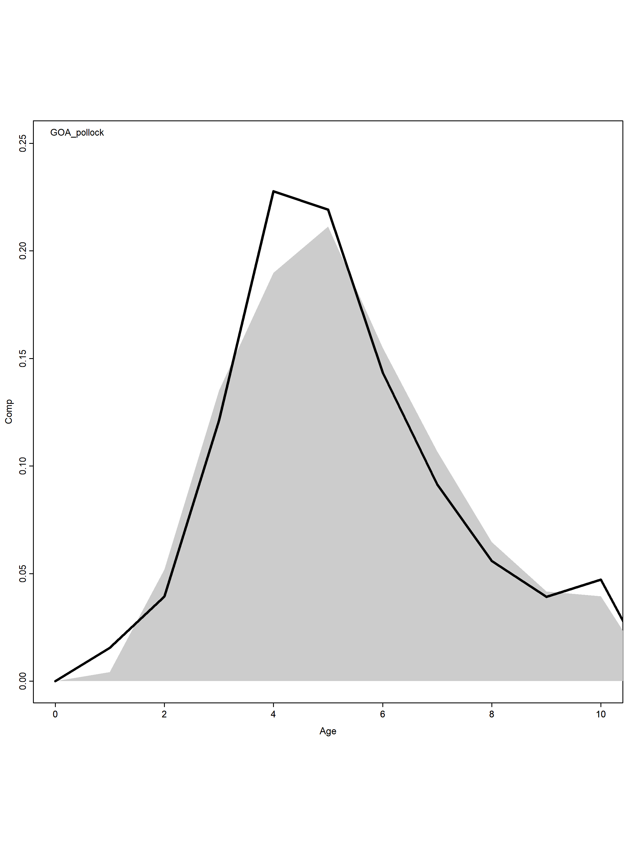

Aggregated fit to fishery length comp.

